COMP 3948
Assignment 2
Linh Hoang
November 30, 2025

Table of Contents
Introduction 3
Report: Exploratory Data Analysis 4
Model Evaluation Summary 12
Conclusion 14

Introduction
This project aims to build a reliable model for predicting whether an individual is a good or bad credit risk using the attributes provided in the Credit dataset. Because many variables in this dataset are categorical, noisy, and highly correlated, the central challenge is identifying a compact set of features that provides strong predictive power without overfitting.
To address this, three feature-selection approaches—Recursive Feature Elimination (RFE), Forward Feature Selection (FFS), and Chi-Square filtering—were applied to the fully preprocessed dataset. Their outputs were combined to create a feature pool, from which 10 systematic experiments were performed using different subsets of features. Each experiment was evaluated using 10-fold stratified cross-validation, ensuring that performance reflected true generalization rather than chance variation.
Through these experiments, a final set of 12 high-value features was identified, including checking status, credit amount, credit history, age group, employment, property status, savings status, and housing. These features consistently appeared across multiple selection methods and delivered competitive F1-scores while minimizing redundancy.

Report: Exploratory Data Analysis
Overall, the original dataset contains 750 rows of data, with 20 columns of features. The number of numeric columns are seven.
There are two columns with missing values, one is numeric which is imputed with K-nearest neighbor algorithm (KNNImputer), and the most frequent value is used for imputing the categorical column with missing values.
After preprocessing, there are total 48 columns of feature. Belows are the analysis of the most significant features selected for the production train.

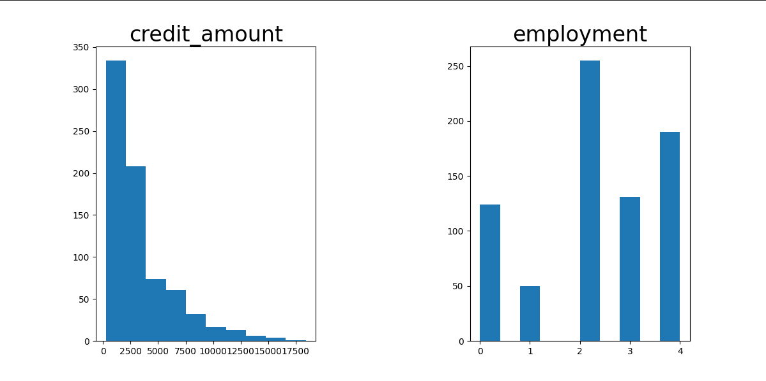
Figure 1. Histograms of numeric features

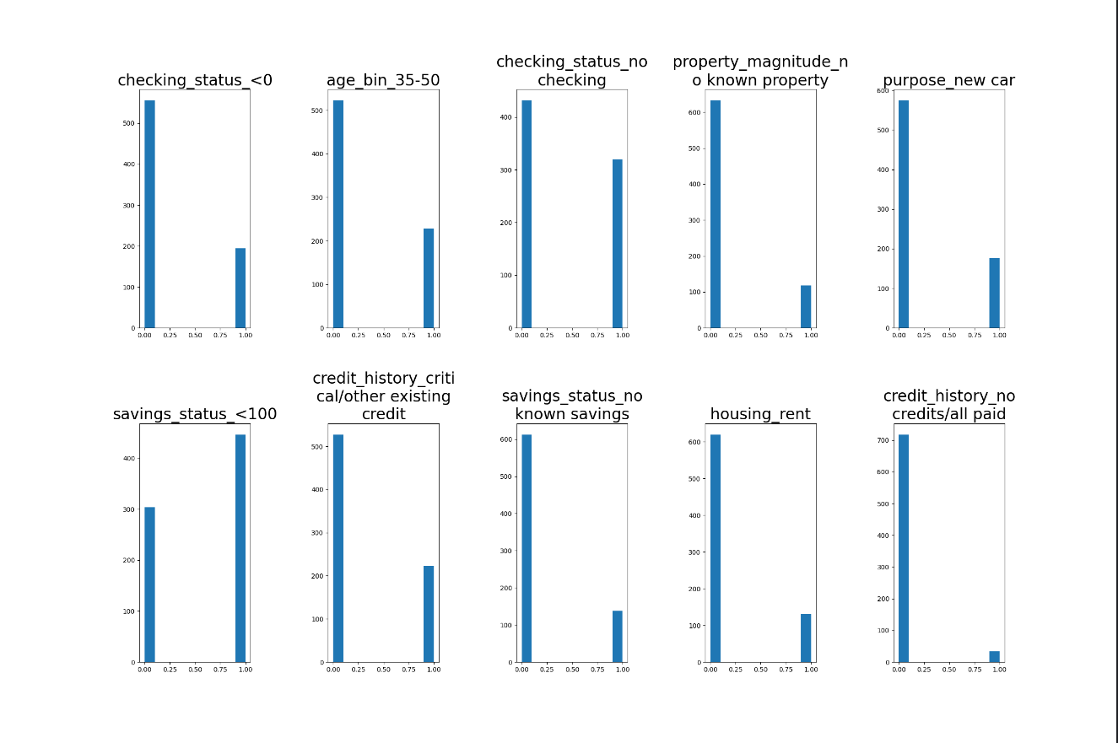
Figure 2. Histograms of binary (dummy) features

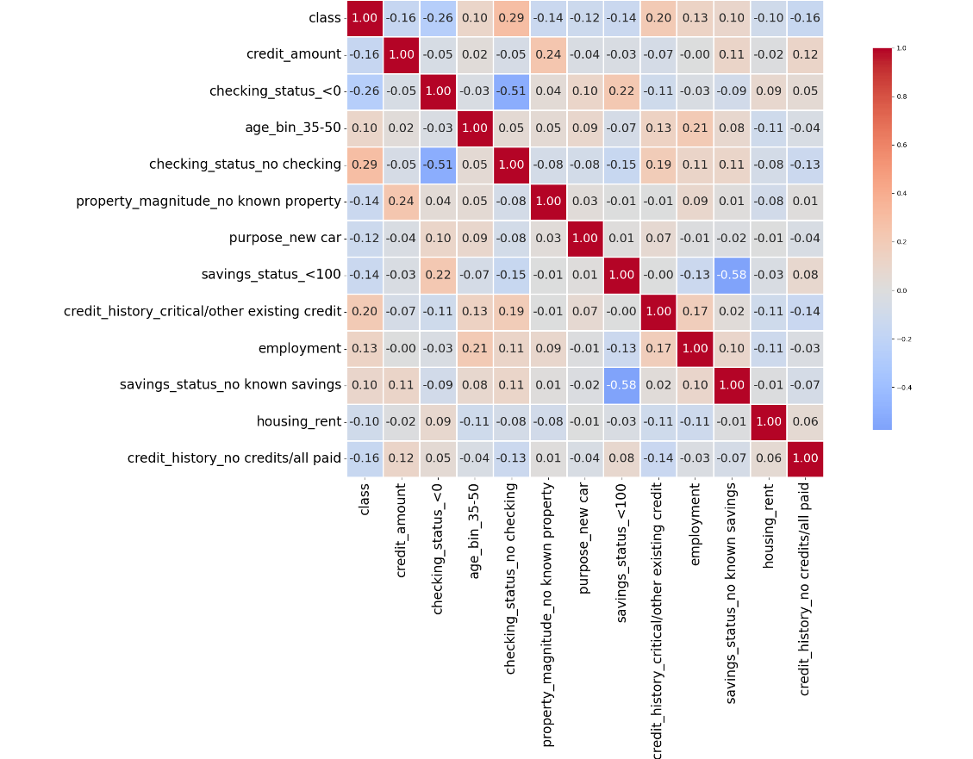
Figure 3. Heat map of selected features and target
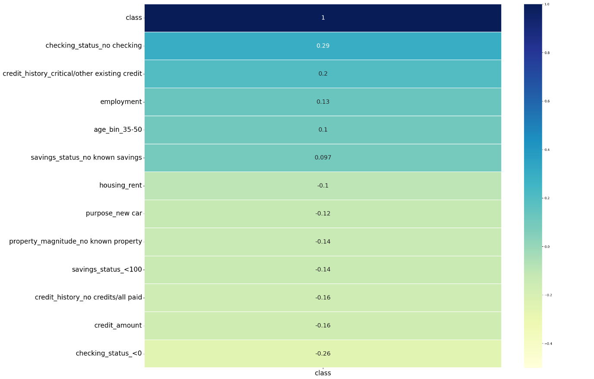
Figure 4. Scatter Matrix of Predictor Variables

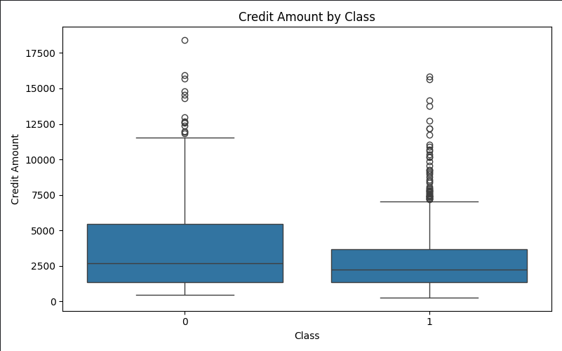
Figure 5. Box plot of credit_amount vs class 1

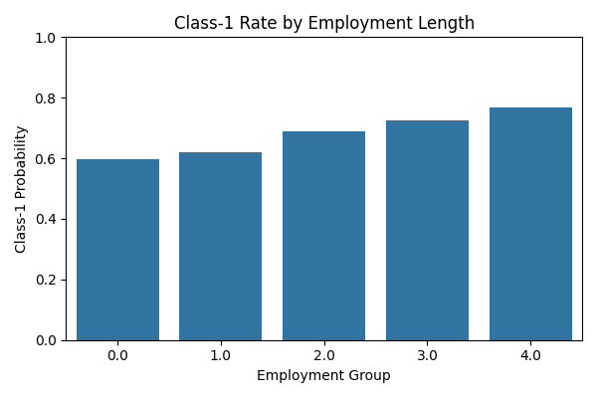
Figure 6. employment vs. class 1
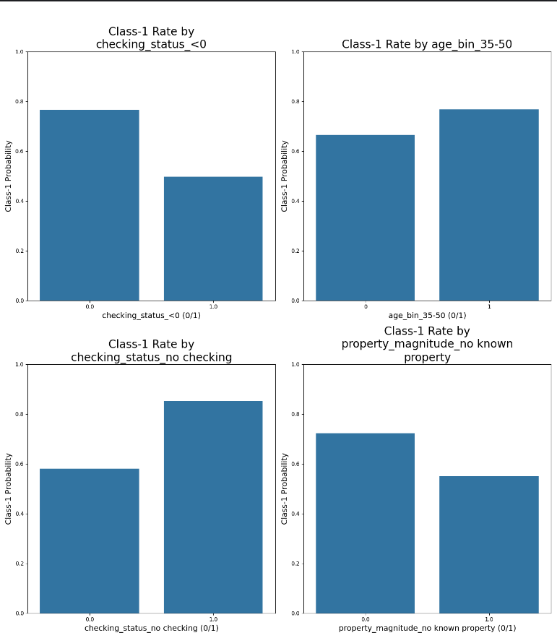
Figure 7. Binary variables vs. class 1 (1)
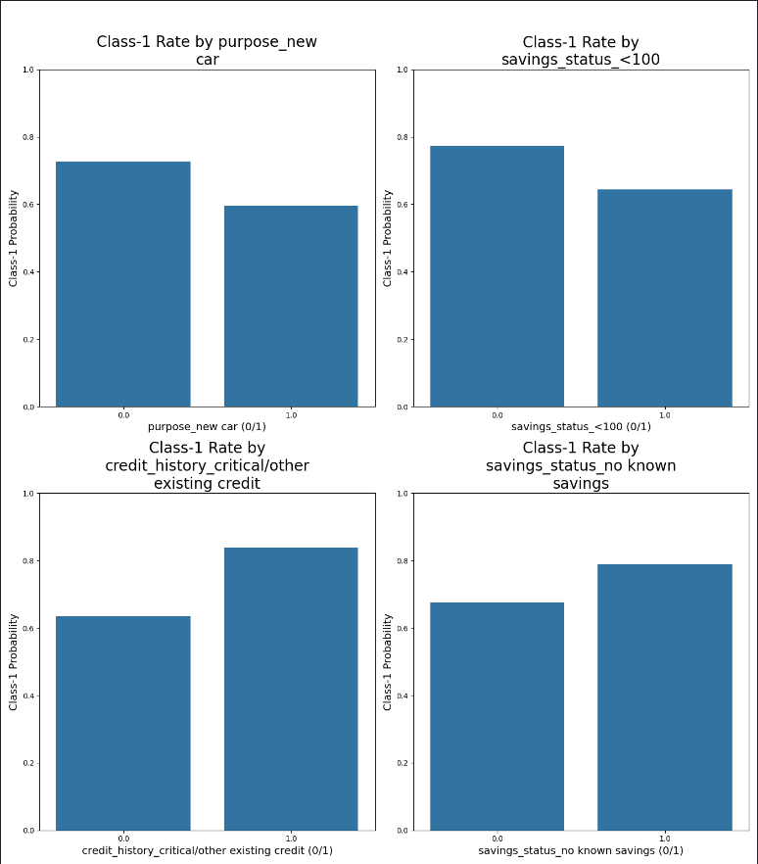
Figure 8. Binary variables vs. class 1 (2)
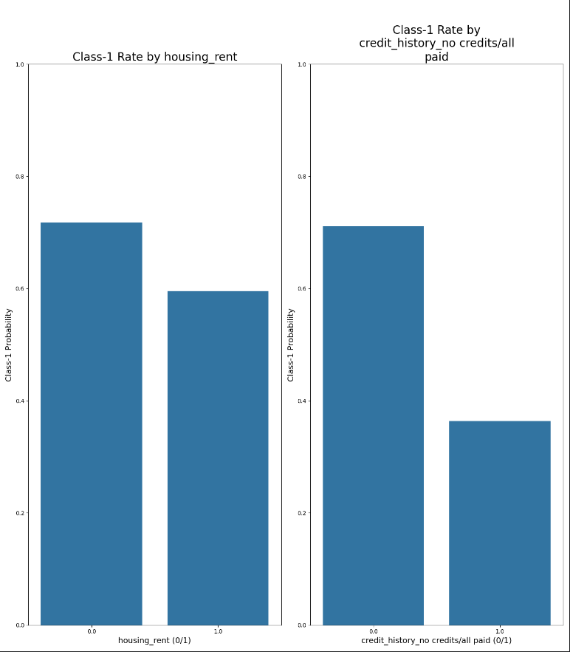
Figure 9. Binary variables vs. class 1 (3)
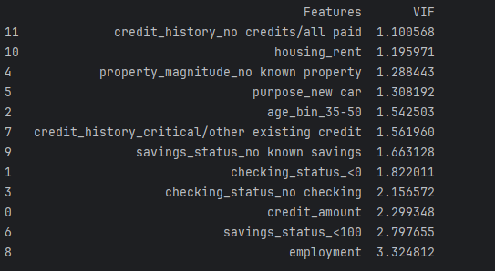
Figure 10. Variance Inflation Factors

Model Evaluation Summary
Standard Deviation from mean is to the left of the ± of each metric.
Here are average metrics of models run over 50 iterations for four different combinations of features.
Features | No. | Precision | Recall | Accuracy | F1 | Macro F1
'duration', 'credit_amount', 'employment', 'installment_commitment', 'existing_credits', 'age_bin_25-35',  'age_bin_35-50', 'age_bin_50-65', 'age_bin_65+', 'checking_status_<0', 'checking_status_no checking', 'credit_history_critical/other existing credit', 'credit_history_delayed previously',  'credit_history_existing paid', 'credit_history_no credits/all paid', 'purpose_education',  'purpose_new car', 'purpose_used car', 'savings_status_>=1000', 'savings_status_no known savings',  'personal_status_male single', 'property_magnitude_real estate', 'other_payment_plans_none', 'housing_own',  'own_telephone_yes', 'foreign_worker_yes' | 26 | 0.7814 ± 0.0250 | 0.9003 ± 0.0329 | 0.7536 ± 0.0329 | 0.8363 ± 0.0221 | 0.6677 ± 0.0473
'duration', 'credit_amount', 'employment', 'installment_commitment', 'age_bin_25-35', 'age_bin_35-50', 'age_bin_50-65', 'checking_status_<0', 'checking_status_no checking',  'credit_history_critical/other existing credit', 'credit_history_delayed previously', 'credit_history_existing paid', 'purpose_education', 'purpose_furniture/equipment', 'purpose_new car',  'purpose_radio/tv', 'purpose_used car', 'savings_status_no known savings', 'personal_status_male single',  'housing_own', 'job_skilled', 'job_unemp/unskilled non res', 'job_unskilled resident', 'own_telephone_yes',  'foreign_worker_yes' | 25 | 0.7698 ± 0.0259 | 0.8967 ± 0.0339 | 0.7396 ± 0.0347 | 0.8280 ± 0.0232 | 0.6444 ± 0.0505
'checking_status_<0', 'duration', 'credit_amount', 'installment_commitment', 'age_bin_25-35',  'age_bin_35-50', 'age_bin_50-65', 'age_bin_65+', 'checking_status_no checking', 'credit_history_critical/other existing credit', 'credit_history_delayed previously', 'credit_history_existing paid', 'purpose_education', 'purpose_new car', 'savings_status_<100',  'housing_own', 'foreign_worker_yes' | 17 | 0.7695 ± 0.0222 | 0.9030 ± 0.0310 | 0.7425 ± 0.0288 | 0.8306 ± 0.0189 | 0.6451 ± 0.0461
'credit_amount', 'checking_status_<0', 'age_bin_35-50', 'checking_status_no checking',  'property_magnitude_no known property', 'purpose_new car','savings_status_<100',  'credit_history_critical/other existing credit', 'employment', 'savings_status_no known savings', 'housing_rent', 'credit_history_no credits/all paid' | 12 | 0.7538 ± 0.0197 | 0.9271 ± 0.0280 | 0.7368 ± 0.0272 | 0.8312 ± 0.0176 | 0.6151 ± 0.0455

Conclusion
The final model uses 12 carefully selected features that consistently delivered strong predictive performance across repeated evaluations. Although all four feature combinations performed competitively, Combination 4 provided the best balance between predictive strength, model simplicity, and low multicollinearity, as confirmed by the VIF analysis (all VIF values < 2.5) (Figure 10). This indicates that the final selected features contribute independent, non-redundant information, which supports a more stable and interpretable logistic regression model.

Strengths
Overall, the model shows strong capability in predicting the target outcome, achieving:
- High recall (~0.93) → the model is very effective at identifying class-1 cases
- Strong F1 (~0.83) → good balance between precision and recall
- Stable performance across 50 randomized runs
- Efficient feature set (12 variables) avoids unnecessary complexity and reduces overfitting risk.

Potential Improvements
The final model is trained with biased class 1, with more weight assigned to class 1, however the performance (F1 score) seems to improve only by 3% indicating that Logistic Regression model may not be the best fit model for this problem. These are the options that should be explored:
- Exploring ensemble models (e.g., Gradient Boosting or Random Forests) could improve nonlinear relationships.
- Collecting more training data, particularly for minority class observations, would further stabilize the model.

